MOLDOVA STATE UNIVERSITY
FACULTY OF MATHEMATICS AND COMPUTER SCIENCE
DEPARTMENT OF COMPUTER SCIENCE

Laboratory Work №2
Discipline: Artificial Intelligence in Game Engine
Topic: "Implementing a Game AI Using the Minimax Algorithm"

Instructor: Treticova Elizaveta
Student: Ciochina Eric
Group: DJ2503

Chișinău, 2026

Objective
The goal of this lab is to make an AI player for a two-player game that uses the Minimax algorithm. The AI has to look at the possible moves, think about how the opponent can answer, and choose the move that gives the best result, assuming the opponent also plays his best.
Task
In the task the basic option was Tic-Tac-Toe 3x3. I decided to make it a bit harder and did Tic-Tac-Toe on a 5x5 board, where you win only if you get 5 in a row (horizontal, vertical or diagonal). The game is Human vs AI and I made it in Unity 6 with C#.
In my game the player puts a black square and the bot (the AI) puts a red triangle. The number of wins is shown in the corners of the screen (Player, Bot and Draws). There are also three buttons: New Game, First move (to choose who starts) and Reset Score.
How Minimax works in my game
Minimax goes through the tree of possible moves. On the bot's turn it takes the move with the highest score (MAX), and on the player's turn it expects the move with the lowest score (MIN), because the player will try to make it worse for the bot. The scores for the end of the game are:
AI wins = +10
Human wins = -10
Draw = 0
I also subtract 0.1 for every move, so the bot prefers to win faster and to lose later.
The problem with 5x5 is that the tree is too big. On 3x3 there are about 362 thousand games, but on 5x5 there are around 25! move orders, so the computer can not check everything at the start. Because of this I added some things:
1. Alpha-beta pruning - it skips branches that can not change the result, so the search is much faster but the chosen move is the same.
2. The bot searches 1 move ahead, then 2, then 3 and so on until 2 seconds pass (iterative deepening).
3. If the search stops before the end of the game, the position gets an approximate score from -5 to +5 (it counts the lines where only the bot or only the player has marks). It is always smaller than a real win, so it can not confuse the bot.
In the middle of the game there are less free cells and the bot can already search the whole tree till the end.
The Minimax search runs in a separate thread (Task.Run) so the game does not freeze while the bot is thinking. The player does not see the scores, I only print them in the Unity Console.
Code
The project has 6 scripts: Board.cs (the board and the check for 5 in a row), Player.cs, MinimaxAI.cs (the algorithm), SearchResult.cs, TicTacToeGame.cs (the game manager with turns, score and buttons) and CellView.cs (one cell of the board). Here is the main part of the Minimax from MinimaxAI.cs:
float ScoreMove(int m, int player, int depth, int ply, float alpha, float beta)
{
bool win = board.Place(m, player);
float s;
if (win)
s = player == me ? WinScore - PlyPenalty * ply : LossScore + PlyPenalty * ply;
else if (board.EmptyCount == 0)
s = DrawScore;
else if (player == me)
s = MinValue(depth - 1, ply + 1, alpha, beta);
else
s = MaxValue(depth - 1, ply + 1, alpha, beta);
board.Undo(m);
return s;
}

float MaxValue(int depth, int ply, float alpha, float beta)
{
if (TimeUp()) return 0f;
if (depth == 0) return board.Evaluate(me);

float best = float.NegativeInfinity;
int count = OrderMoves(ply, me);
int[] moves = moveBuffer[ply];
for (int i = 0; i < count; i++)
{
float s = ScoreMove(moves[i], me, depth, ply, alpha, beta);
if (s > best) best = s;
if (best > alpha) alpha = best;
if (alpha >= beta) break;
}
return best;
}

float MinValue(int depth, int ply, float alpha, float beta)
{
if (TimeUp()) return 0f;
if (depth == 0) return board.Evaluate(me);

float best = float.PositiveInfinity;
int count = OrderMoves(ply, opp);
int[] moves = moveBuffer[ply];
for (int i = 0; i < count; i++)
{
float s = ScoreMove(moves[i], opp, depth, ply, alpha, beta);
if (s < best) best = s;
if (best < beta) beta = best;
if (alpha >= beta) break;
}
return best;
}

Screenshots

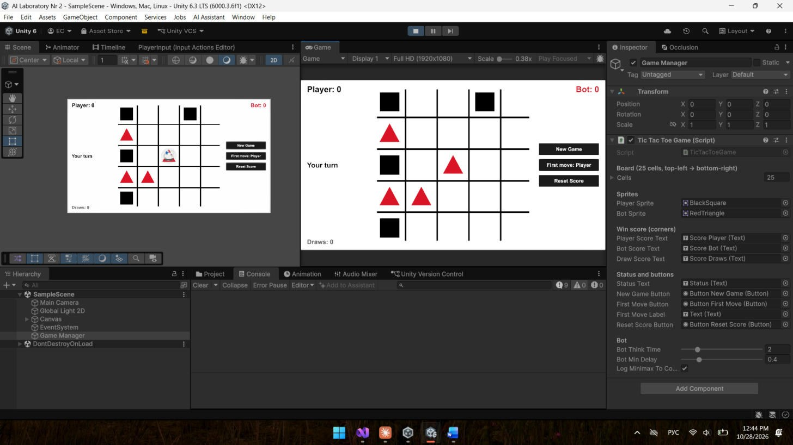
Screenshot 1. The game running in Unity, middle of the game.
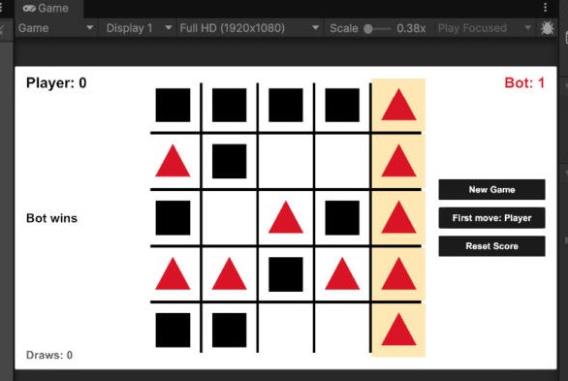
Screenshot 2. The bot won with 5 triangles in the last column.
Testing
I played several games against the bot and could not beat it. If I make a mistake, the bot finds the 5 in a row and wins, like in Screenshot 2. I also let the Minimax play against itself on 5x5 and all games ended in a draw, and on a 3x3 board it never lost.
Conclusion
In this lab I made a Tic-Tac-Toe 5x5 game in Unity where the AI plays with the Minimax algorithm. The AI builds the tree of moves, chooses the maximum on its turn and the minimum on the player's turn, and uses +10, -10 and 0 for the end of the game. Because 5x5 is much bigger than 3x3, I used alpha-beta pruning and a time limit to make it work fast. The bot is very hard to beat and the best result against it is usually a draw.

